

|  |  |  |
| --- | --- | --- |
| Mathematics Department | |  |
| Course: ATMAA | |
| Topic Title: Bivariate data  Test 2 | |
| Student Name:\_\_\_\_\_\_\_\_\_\_\_\_\_\_\_\_\_\_\_\_\_\_\_\_\_\_\_\_\_\_\_\_\_\_\_\_\_ | Date: \_\_\_\_\_\_\_\_\_\_\_\_ | | |
| Special Instructions: Calculator Free  **Formula Sheet Allowed** | Time Allowed: 15 mins | | |
|  | Marks: / 14 | | |

**Question 1.** (1 mark)

Which of the following scatter plots has a linear relationship?

|  |  |  |
| --- | --- | --- |
| Chapter_02TT1_UN001A | Chapter_02TT1_UN002B | Chapter_02TT1_UN003C |
| Chapter_02TT1_UN004D | E None |  |

**Question 2.** (1 mark)

Pearson’s correlation coefficient is a measure of the strength of the relationship between two variables and must vary between the values:

A −1 to 0

B  0 to 1

C −1 to 1

D −10 to 10

E   None of the above

The following information relates to Questions 3, 4 and 5.

The following least-squares regression line models data collected about the height (metres) of trees and the number of years they have been planted.

*Height* = 0.9 + 1.2 × Years planted

**Question 3.** (1 mark)

The predicted height of a tree that has been planted for 5 years is:

A  6 metres

B  6.4 metres

C 6.9 metres

D 720 centimetres

E 600 centimetres

**Question 4.** (1 mark)

Which one of the following statements is false?

A When planted, a tree is 0.9 metres tall.

B The height of a tree increases as the years it has been planted increase.

C There is a positive correlation between heights and years planted.

D The height of a tree decreases by 1.2 metres for every 1 year it increases in age.

E The height of a tree depends on the number of years it has been planted.

**Question 5.** (1 mark)

A tree that had been planted for 10 years measured 12.1 metres tall. The residual value for a tree

that has been planted for 10 years is:

A  0.8 metres

B − 0.8 metres

C 1 metre

D −1 metre

E None of the above

The following information relates to Questions 6 and 7.

A class of students sat for a Biology test as well as a Chemistry test. The scatter plot below displays the results with the regression model fitted.

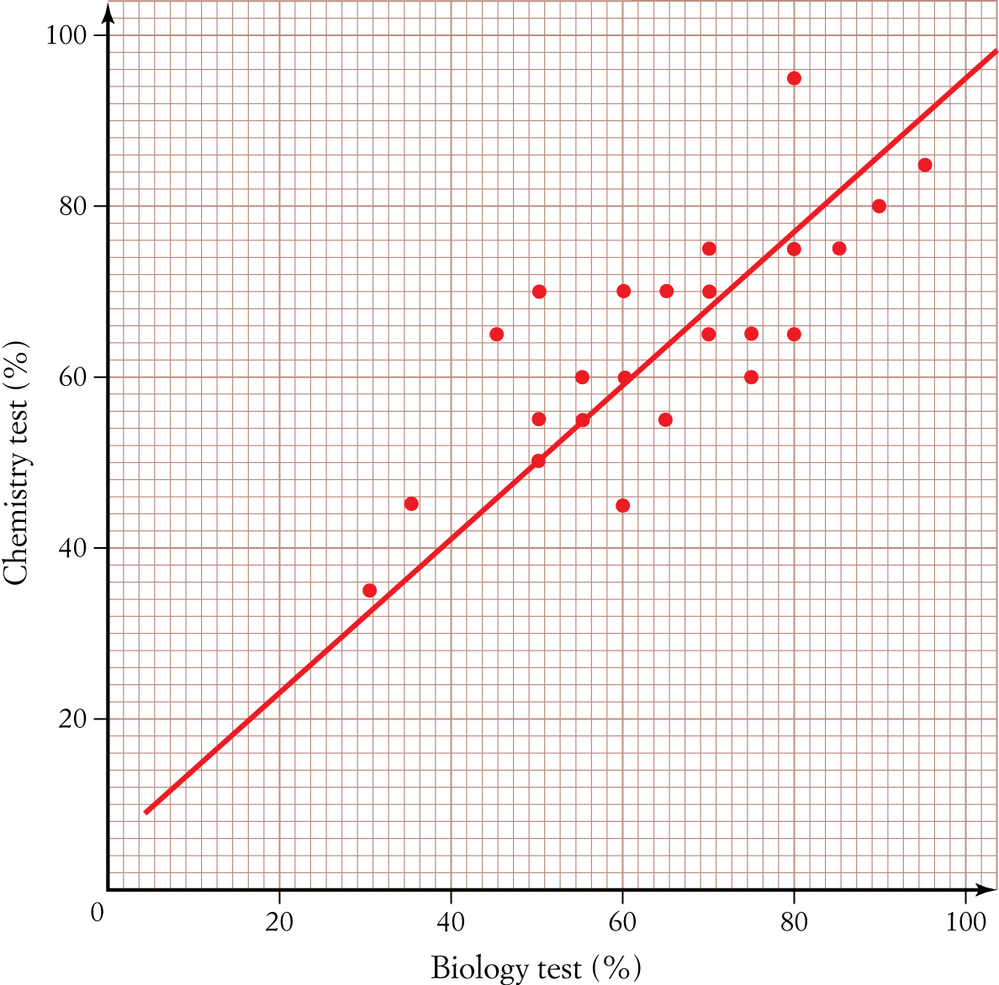

**Question 6.** (1 mark)

If a residual plot was constructed for these data it would have:

A  Ten negative residual values

B Five residual values of 0

C Fifteen positive residual values

D All positive residuals

E All negative residuals

**Question 7.** (1 mark)

The regression line was used to predict the Chemistry test result for a student who received 20% for their Biology test result. Which one of the following statements is *true*?

A The prediction will be that the Chemistry test result will be approximately 80%.

B  The prediction will be reliable, as it is an example of interpolation.

C The prediction will be reliable, as it is an example of extrapolation.

D The prediction will not be reliable, as it is an example of extrapolation.

E The prediction will not be reliable, as it is an example of interpolation.

**Question 8.** (1 mark)

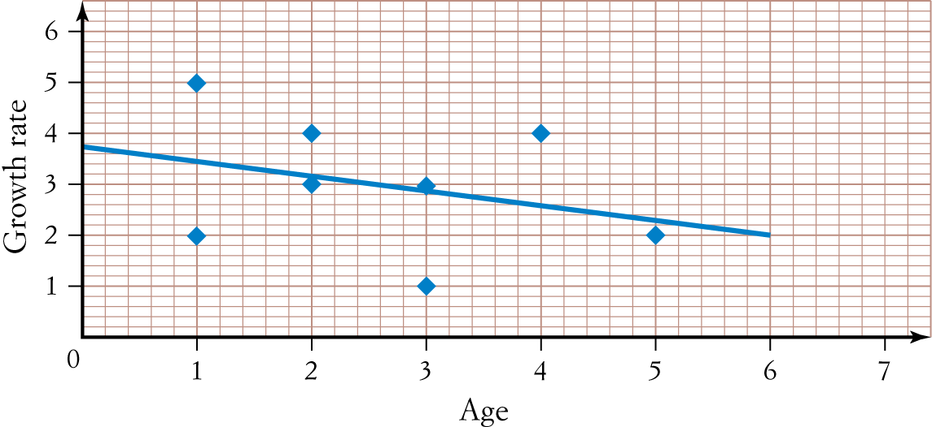

The plot of the residuals against Age is closest to:

A B

|  |  |
| --- | --- |
| Chapter_02TT1_UN008Chapter_02TT1_UN007C D |  |
| Chapter_02TT1_UN010aChapter_02TT1_UN009E |  |
| Chapter_02TT1_UN010b |  |
| **Question 9.** (1 mark)  The height (in cm) and weight (in kg) of 10 students were recorded and are displayed in the scatter  plot below.  Chapter_01TT1_UN011The relationship between the height and the weight of the students is best described as:  A Moderately positive linear relationship  B Moderately negative linear relationship  C Moderately positive non-linear relationship  D Weakly positive linear relationship  E No relationship |  |
| **Question 10.** (1,1: 3 marks)  The table below shows some information about car accidents in Australia. It shows the percentage of car accidents by type of road being driven on, for three different age groups.   |  |  |  |  | | --- | --- | --- | --- | | Type of road | Age of driver in car accident | | | | 18 to 30 years | 31 to 50 years | Over 50 years | | Inner city | 43% | 51% | 17% | | Country | 32% | 32% | 48% | | Freeway | 25% | 17% | 35% | |  |
|  |  |

a) Of the car accidents involving drivers over 50 years of age, what percentage occurred on country roads or freeways?

b) Does the information in the table support the opinion that the age of drivers in car accidents is associated with the type of road on which they were driving? Justify your answer by quoting appropriate percentages from one age group only.

**Question 11.** (2 marks)

For the following sets of variables, state which is the explanatory variable and which is the response variable.

a) Amount of daily exercise and fitness level

b) Price for which a car sells and the age of the car